

**Batch: A1 Roll No.: 16010121045**

**Experiment / Assignment / Tutorial No:**

|  |
| --- |
| **TITLE:** To formulate visually pleasing (color, screen based controls) design for the product/application under consideration. |

**Objective:** To study and explore the color theory for visually pleasing design along with the importance of screen based controls.

______________________________________________________________________

**Expected OUTCOME of Experiment:**

**CO3: Illustrate the working of UX design process.**

**______________________________________________________________________**

**Books/ Journals/ Websites referred:**

[**https://baymard.com/learn/ux-design-process**](https://baymard.com/learn/ux-design-process)

**______________________________________________________________________**

**New Concepts to be learned:**

1. Color Psychology.
2. Web Content Accessibility.
3. Screen based controls.

**Background Theory:**

In digital design, both **color theory** and **screen-based controls** play crucial roles in enhancing user experience and interaction. Effective use of color creates an aesthetically pleasing interface, conveys meaning, and guides users, while screen-based controls ensure smooth and intuitive interaction between the user and the system.

**Importance of Color Theory**

**Color theory** refers to the study of colors and their combinations to create specific aesthetics, moods, or visual impacts. It involves understanding how different colors interact, the emotional responses they evoke, and how they can enhance user experience in design.

1. **Improves Visual Hierarchy:**  
   Color helps to establish a hierarchy by drawing attention to key elements like buttons, headers, or calls-to-action (CTA). Bright, contrasting colors make important elements stand out, while muted colors can indicate secondary or background content.
2. **Enhances Usability:**  
   Colors can help make interfaces more intuitive by signaling user expectations. For example, green is often associated with approval or success (e.g., "Submit" buttons), and red indicates errors or warnings.
3. **Improves Accessibility:**  
   Thoughtful color choices make designs accessible to users with visual impairments, such as color blindness. Designers need to ensure enough contrast between text and background and use additional visual cues beyond just color to convey meaning.
4. **Creates Emotional Impact:**  
   Colors can evoke specific emotions. For example, warm colors like red and orange evoke excitement, energy, or warmth, while cooler tones like blue and green are more calming, signifying trust or security.
5. **Brand Recognition and Identity:**  
   Consistent use of colors helps to establish and strengthen brand identity. A brand's color palette contributes to its recognition and helps communicate its values and personality.

**Use of any tool (Open Source) to design**

* Pamphlet for marketing your product
* Application of relevant color principles on above design
* Apply web accessibility principle for your website
* Color Blindness Accessibility

**Conclusion from Virtual Lab activity.**

**Good Color Combination:**

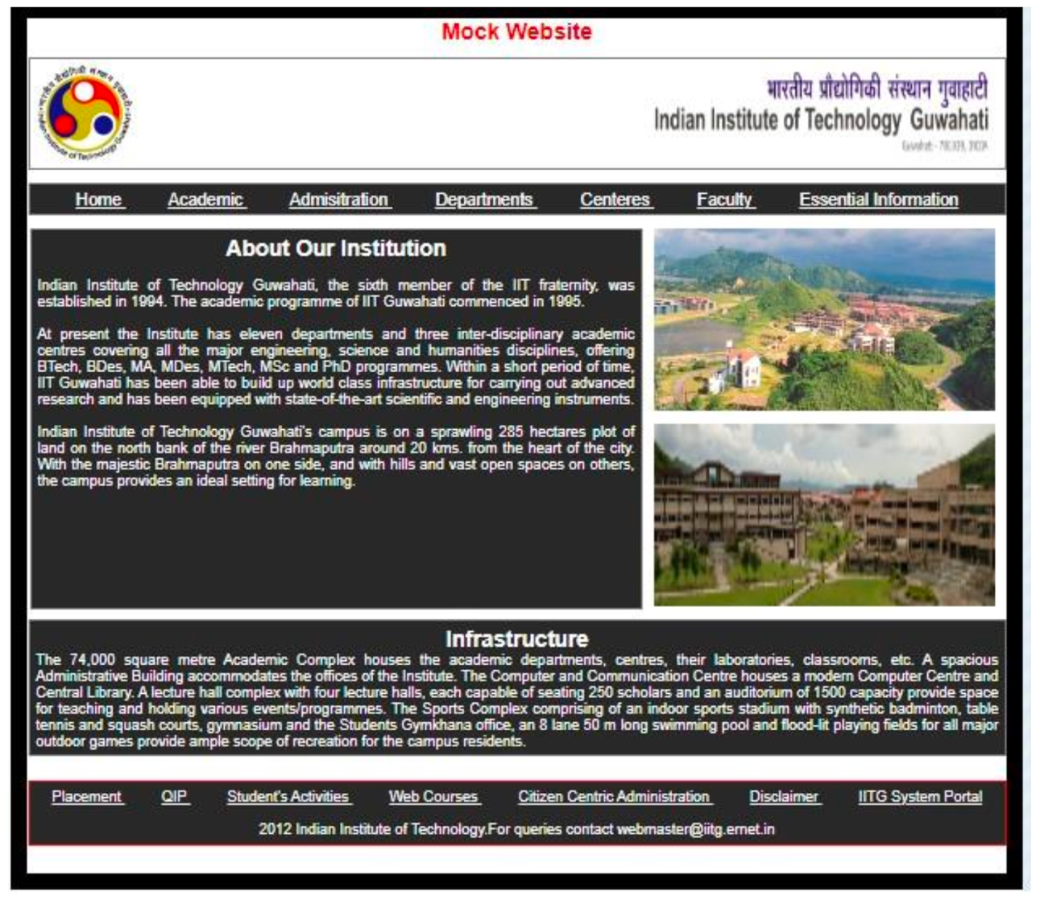

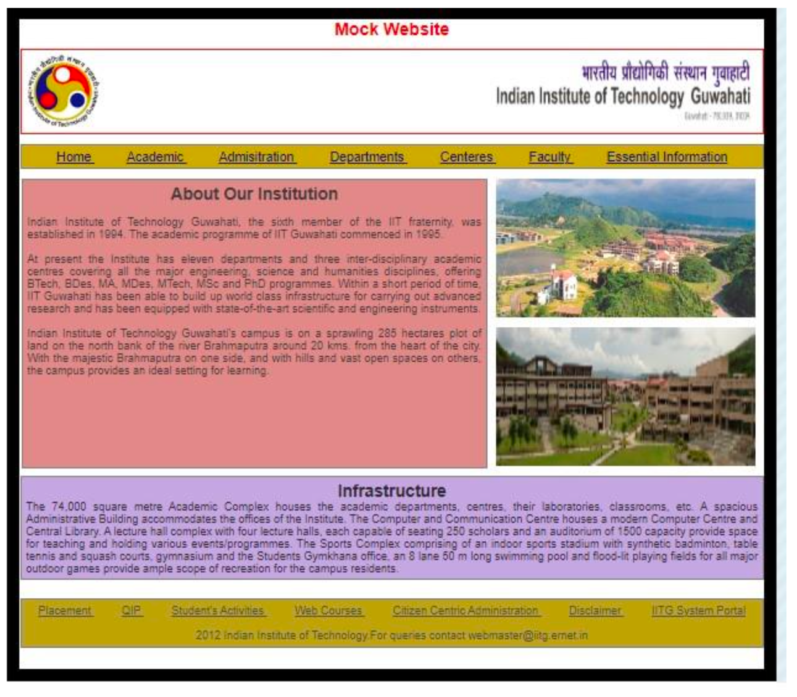

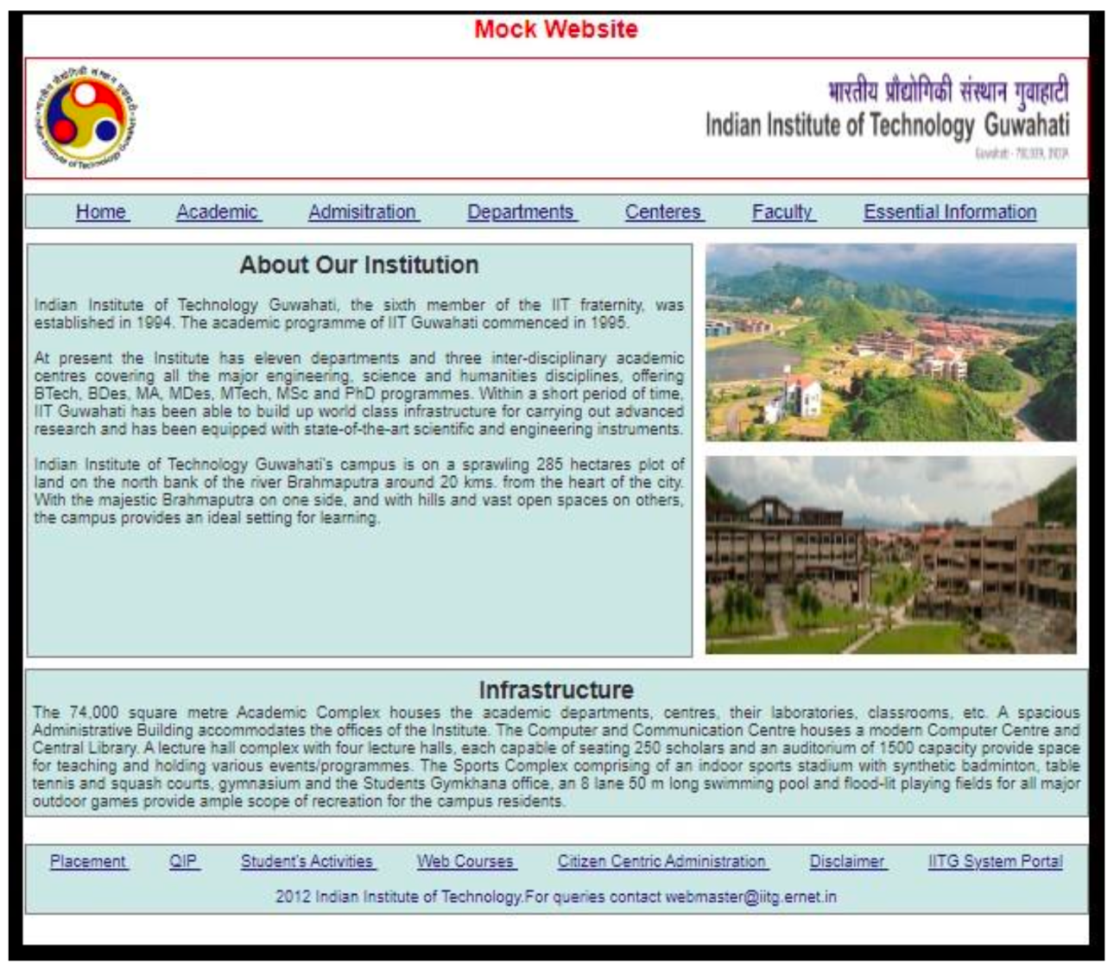

**Bad Color Combinations:**

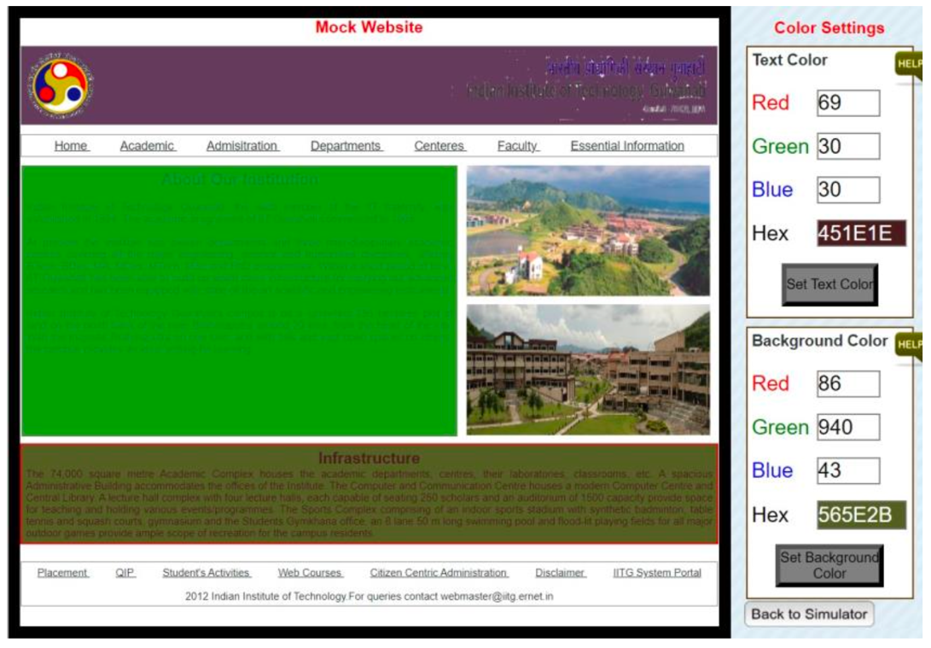

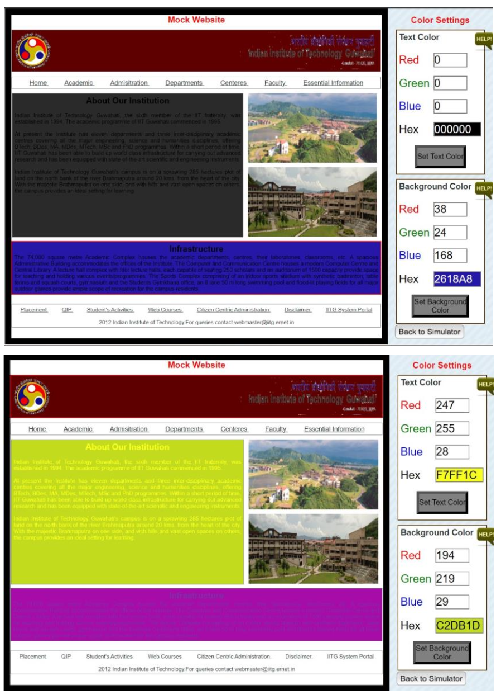

**Screen based controls:**

Screen-based controls are the elements on an interface that allow users to interact with the system through input, navigation, or commands. These controls are vital for usability, ensuring users can easily perform tasks and access the information they need.

**Importance of Screen-Based Controls**

1. **Enhances User Interaction:**  
   Controls provide a means for users to interact with the digital interface, whether it’s navigating through pages, inputting data, or manipulating elements. Well-designed controls ensure that interaction is easy and intuitive.
2. **Improves Usability:**  
   Clear, well-placed controls that follow established conventions improve the ease with which users can understand and interact with a system, reducing frustration and improving satisfaction.
3. **Guides User Behavior:**  
   By defining the limits of possible actions, screen-based controls guide users through their journey on an app or website. For instance, disabling buttons when an action is not possible prevents user confusion.

**Types of Screen based controls with brief description.**

Here is a brief description of common types of screen-based controls:

1. **Text Input Fields:**  
   These allow users to input data such as text, numbers, or passwords. Input fields often come with labels and placeholders to guide users on what to enter.
2. **Buttons:**  
   Buttons are interactive elements that perform actions when clicked or tapped. They are commonly used for submitting forms, triggering commands, or navigating between screens.
3. **Checkboxes:**  
   Checkboxes allow users to select one or more options from a list. They are often used in forms or settings where multiple selections are allowed.
4. **Radio Buttons:**  
   Similar to checkboxes, but radio buttons allow users to select only one option from a group of choices. Once an option is selected, the others become unselectable.
5. **Dropdown Menus:**  
   Dropdown menus allow users to choose an option from a list that appears when the menu is clicked. This is useful for saving screen space when there are multiple options.
6. **Sliders:**  
   Sliders allow users to select a value from a range by moving a handle along a track. They are often used for settings like volume control or brightness adjustment.
7. **Toggle Switches:**  
   Toggle switches are used to turn settings on or off. They often appear in mobile apps or device settings and allow users to enable or disable features quickly.
8. **Navigation Menus:**  
   Navigation menus provide users with links to different parts of an application or website. They can be horizontal, vertical, or dropdown in structure.
9. **Progress Bars:**  
   Progress bars visually indicate the completion status of a task, such as file uploads or form submissions. They provide feedback on how much time is left or how much has been completed.
10. **Modals/Popups:**  
    Modals are overlay windows that display content or options while temporarily blocking interaction with the underlying page. They are used for alerts, forms, or important messages.

**Selection of appropriate screen based controls for the application/product under consideration with proper justification:**

1. **Splash Screen:**
   * Simple and clean design featuring the bank's logo and tagline.
   * **Justification:** The splash screen provides brand recognition and sets the tone for the app experience.
2. **Login Screen:**
   * Includes options like "Quick Login" and "Login with Password."
   * Use of icons for other login options like fingerprint.
   * **Justification:** Provides a quick and secure way for users to log in using familiar methods.
3. **Home Page:**
   * Presents the account balance and recent transactions.
   * **Quick Actions** section uses icon-based buttons for frequent tasks (e.g., transfer money, bill payments).
   * **Justification:** Offers users a snapshot of their account and easy access to key features. Icon-based buttons make the interface intuitive and easy to navigate.
4. **Payments Screens:**
   * Tabs for Credit Cards and Debit Cards, providing detailed information on transactions and limits.
   * Use of buttons like "Pay Now" for quick actions.
   * **Justification:** Organizes complex information (e.g., credit card details) in a digestible manner. The use of buttons for payment actions facilitates user engagement.
5. **UPI Screen:**
   * QR code scanning for easy UPI payments.
   * **Justification:** Directly addresses user needs for quick payments using UPI, which is a widely used feature in banking apps.
6. **Profile and Contact Details:**
   * Displays user's profile with options to edit contact details.
   * **Justification:** Offers a personalized touch and ensures users can manage their information effortlessly.
7. **Statements and Unbilled Transactions:**
   * Provides a clear, tabular view of transactions with download options.
   * **Justification:** Offers transparency and easy tracking of spending, which is essential for a banking app.

**Results & Screenshots of Color theory and screen based controls for selected application/product:**

The app uses HDFC's brand colors, primarily **blue** and **red**, to reinforce brand identity and create a consistent visual experience. Blue is dominant throughout the interface, conveying trust, security, and professionalism—key attributes for a banking application. Red is strategically used to highlight important elements, such as credit card limits and alerts, drawing the user's attention to critical information.

**White** and **gray** backgrounds provide a clean canvas, ensuring that text, icons, and buttons stand out for enhanced readability and usability.

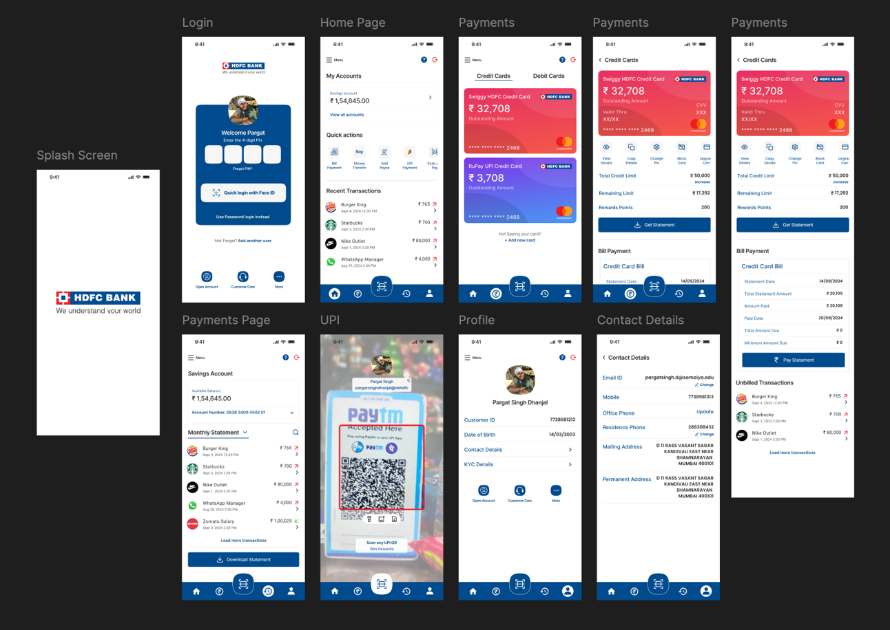

**Justification:** The consistent use of HDFC's brand colors not only strengthens brand recognition but also guides users through the app's features in an intuitive manner. The color palette supports a clear information hierarchy, making the app look reliable and user-friendly.

**Conclusion:**

In conclusion, understanding and applying **color theory** is essential for creating visually appealing designs that not only engage users but also guide their interactions. The design choices in this banking app wireframe utilize screen-based controls effectively, offering an intuitive, secure, and user-friendly experience. The color scheme reinforces the brand identity and ensures a clear hierarchy of information, guiding users through various banking tasks seamlessly.